12/7/2018

Arasan Dayalan

9884163559

F2 Renovation

SRM Kausthub

Contents

OBJECTIVES 2

LAYOUT 3

WINDOWS 4

DOORS 5

LOFT 6

HALL 7

TV UNIT 8

BED 11

BEDROOM 1 (12 X 9) 12

BEDROOM 2 (9 X 11) 13

KITCHEN 14

BATH 1 (4 x 6) 15

BATH 2 (6 X 4) 16

PATIO 17

EXTERIOR 18

PENDING 19

PICTURES 21

# OBJECTIVES

* Compact home and thus space is limited
* Provide storage as much possible
* Fittings should be perfect
* Prevention of settling of dust
* All shelves will have doors
* Sufficient natural lighting
* Kid safe construction
* All shelve doors are opaque unless explicitly specified
* All bottom shelves should have locks unless specified otherwise

# LAYOUT

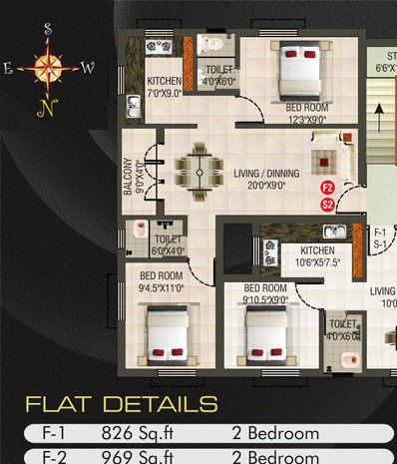

# WINDOWS

* All windows should have mosquito net. Velcro (black) should be used as sticker. High grade net should be used. Bathroom windows and ventilation holes will also need to be done. Velcro extensions for rolling up (the net) not required.
* Verify whether locks of windows are in good condition. Note down any other work to be done on windows

# DOORS

* Mosquito Net door for patio door only. Not required for any other doors. Size should be the same as the door. If possible in off-white color similar to door color. It should open to the left 180 degree and should be lockable in-place.
* Verify whether locks of all doors are in good condition. Note down any other work to be done on doors
* Shall we remove the patio door and just have mosquito door? If so, can outsiders view hall from outside (looks like there is a window)? Will water come if raining?

# LOFT

* Cover all lofts (both bedrooms and kitchen) with doors (PVC or Wood, whichever is cheaper). Color is off-white
* Loft will remain to be continuous and should not be partitioned, which allows to store bigger items and use space efficiently.

# HALL

* Mosquito Net door for patio. Not required for main door.
* Remove existing wash basing and do as below. Embed sink with two doors & lock. On the right, it should have space for hand wash. Change tap if necessary. Color: Off-white

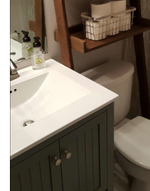

* A large mirror (size will be provided) should be fixed with lights (and switch) above so that it helps during shaving. Also need electric socket (with auto-cutoff) for hair drying.
* Fridge (23 x 65 x 29) will be placed in top left corner but which direction is useful. Don’t think there is place in kitchen.
* Place hall wooden shelf (73 x 37 x 16) in bottom wall right.
* Place dining table (63 x 30x 30) top wall near kitchen
* Place sofa bottom wall middle.
* Place designer wallpaper or mirror in the wall where dining table would be or should I have Pooja stand. Decide.
* Move the tube light to on the left wall to bottom wall, to make space for shelves. Again decide is this can be done. Once shelf is built, no further fixtures can be made. Make sure it does not hit the fan. If this is done, then false ceiling option is dropped.
* (optional) Decide location for a Long Mirror and white board (need 2.5 feet space so that this can fit. Size: 2x3 ft.)
* Entry door to kitchen
* Should there be something being main door. Like photos?

# TV UNIT

* Color: Off-white
* Dimensions: 6 ft. (check this) on either side x 9.5 ft. (check this) high which touches the celling.
* The idea is to build a working desk cum TV unit.
* There should be no gap between the wood frame and the wall. If the gap is tiny, then it has to closed with glue to prevent ants.
* Situated in upper right in hall (as per layout view). 6 feet on either side should allow dining table (longer side) to be placed on the left wall, near kitchen. The entire wall should be covered with wood. This gives flexibility to fix electric sockets / lights wherever required.
* Desk should be 2.5 ft. in height and 1.5 ft. in depth.
* Edges Rounded off (like below). In hall corner, desk should be curved. This curvature provides sufficient leg room. The wall below the desk does not require a wood wall.

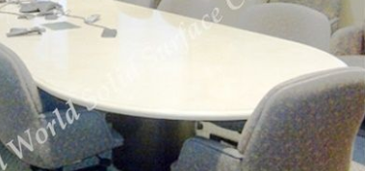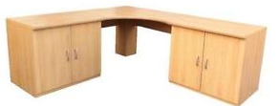

* Shoe shelf, on right wall (near main door) should be the bottom shelf. Size is 1.5 ft. width with single door.
* TV (29 x 18 x 5) will be situated on the left wall. The bottom shelf on TV should be of width 2.5 ft. The height will be 3.5 ft. which raised it above the desk height (that is OK). The lower shelf for 2.5 ft. would be a regular one but the upper shelf with height 0.5 would be glass doors with door opening from top to down (not sideways). If sliding glass door can be provided, it is also fine. This 0.5 ft. shelf should contain holes for wires from TV, electricity sockets & HDMI cable to pass. Make sure in case a sound bar has to be placed, there is sufficient place below the TV. Should the cable wire for Tata Sky be pulled out similar to rented house? Check this. if not present, need to make accommodation for this into the TV unit.
* All bottom shelves should have locks.
* All tops shelves should be similar like loft shelves. Extra support to carry weight must be added, if required. The depth size need not be the same as bottom but not less than 1.5 ft. The top shelf goes beyond the 6 ft. to the top of the main door. This is where inverter unit will be placed (find out if it’s the right place and how it will be fitted to the lines).
* The top corner shelf should have door by itself. There is no bottom corner shelf as it will provide leg space. There is, however, middle corner shelf.

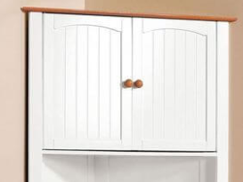

* Similar to top shelves, the middle shelves should extend from right wall to left wall but stop before TV fixture. This means it stops around 3 - 3.5 ft. from corner. The depth of shelves should be 1 ft. instead of 1.5 ft. to prevent head injury. Transparent doors for all middle shelves. Mostly will act as book shelf.

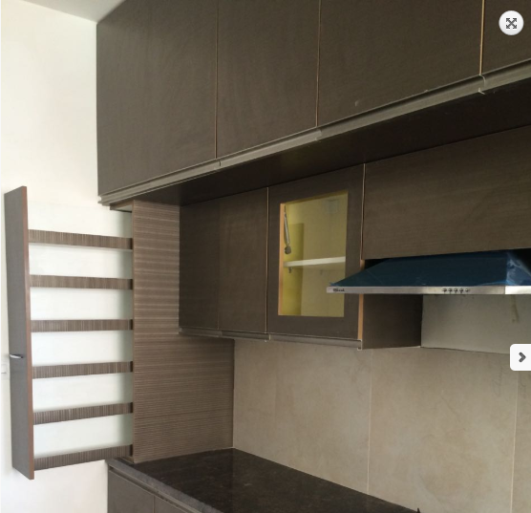

* Lights (with on/off switch) below middle shelves so that working on laptop will be bright.

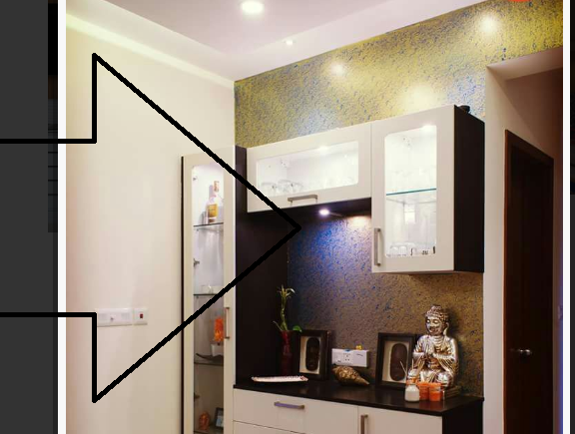

* Throughout the desk, there should be electric sockets.
* Note that there are no drawers in this unit.
* Allow for HDMI cable to be run from TV place into laptop station. Should be concealed (by running below desk) and even replacement should be easy. There also should be holes along the desk so that wires can be pulled up.
* What about lighting, need extra tube light in opposite wall? Will the top shelve interfere with fan and lights? Does cable wire have to be pulled into the TV place? Electricity must definitely be pulled in.
* Decided to not extend upper shelves the top wall beyond 6 feet. In case, we need to do it in future, what to do?

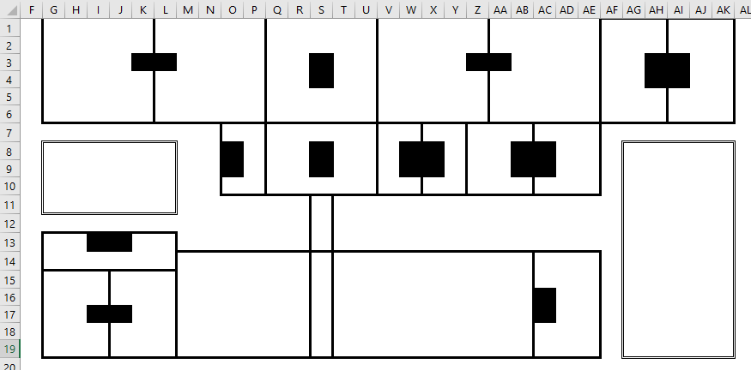

# BED

* Edges Rounded off
* Storage space as drawers as below. Can split drawers as required
* Color: Off-white
* Dimensions: TBD
* 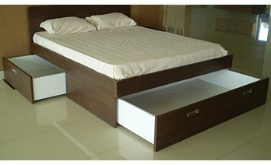
* King bed (76 x 80). Need to check if size will fit room and still have space. Cannot split into stackable beds as need flexibility in # of people sleeping. However, once kids grow, they might have to sleep separately. Think what is best option.
* Mirror in wardrobe or in wall

# BEDROOM 1 (12 X 9)

* Mosquito Net for windows.
* Color: Off-white
* Dimensions: TBD
* Clothesline (2 lines) check where it can be placed
* Wardrobe required??? Not sure if space is there. See if bi-fold doors are possible (lock is problem I guess). Find out which wall should have this.
* 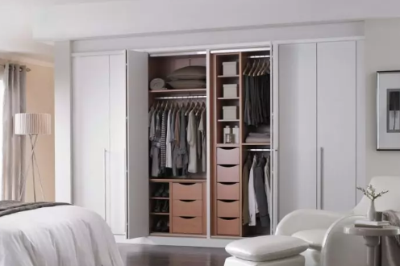
* Used clothes hanger location.
* Mirror in wardrobe or in wall

# BEDROOM 2 (9 X 11)

* Mosquito Net for windows.
* Color: Off-white
* Dimensions: TBD
* Overlook (like below) in the bottom window with cushion and bottom storage
* 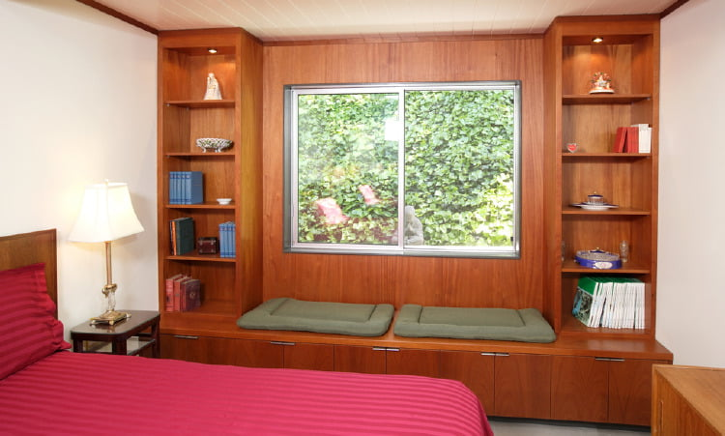
* Clothesline (2 lines). Check where it can be placed.
* Wardrobe should have bi-fold doors (if possible picture above) (lock is problem I guess). Find out which wall should have this.
* Used clothes hanger location.

# KITCHEN

* Mosquito Net for window and ventilation (if present).
* Color: Off-white
* Dimensions: TBD
* First underneath shelf should be a drawer.
* Hold for cylinder pipe
* Make sure the shelves are reachable as Sindhu is short. If reachable with a small stool, that is also fine.
* Chimney above gas stove
* Water Purifier place just above sink. See if shelf can be kept above this. What to do about excess water? Need to accommodate somehow.
* Make a place where water from utensils can be drained. May be a shelf in itself. Like in US home.
* How to close shelves made from granite? Closure possible?
* Space for microwave and connection. Should be reachable easily
* Space for mixie and induction stove
* Extra light for cooking which focusses on stove
* Mosquito Net for exhaust fan

# BATH 1 (4 x 6)

* Mosquito Net for window and ventilation.
* Storage shelves with mirror. However, if more storage can be done, check it out. Dampness will be concern so need plastic storage only
* Towel hangers
* Toiletries rack

# BATH 2 (6 X 4)

* Mosquito Net for window and ventilation.
* Storage shelves with mirror. However, if more storage can be done, check it out. Dampness will be concern so need plastic storage only
* Towel hangers
* Toiletries rack

# PATIO

* Clothesline (5 lines if possible). Can it be extended outside? Check.
* Place for washing machine(dimensions?) Above washing machine if there can be storage place? Earlier decided to have water filter to fill extra water into washing machine but it would be too far. See what can be done. Or run filter pipe into washing machine, which may be long.
* Washing machine (38 x 31 x 20) will fit
* AC fan location.

# EXTERIOR

* Shoe stand
* Generic gate on the floor. Gate should open towards the steps and not inwards

# PENDING

* Removable door for shelves (in loft especially) was not considered
* Dimmer
* Place for sound bar?
* L shape stand /w edge in TV Unit is not considered. Not sure what purpose it will serve. Have to see sample photos. May be do it in the corner when laptop will be used
* Hand soap Foam machine
* Find place for existing items in rented house
* All wooden furniture which stays at floor level, needs to be coated so that during floor mop it does not get damped. Mica / Plastic etc.?
* Find out convenient storage place for diapers / tissues, groceries, toolboxes etc.
* What to do with Pooja / God shelf. Where to keep? Find out. If needed, fit it somewhere and do some work around it. Should paint off-white I guess.
* Motion sensing lights in places where there will be no light. Like wardrobe, kitchen shelf
* Air purifier space?
* Invertor space?
* Find out where to keep clock and make holes for it.
* Space for table fan.
* Redo sofa liner. Find out contact for sofa lining work.
* Security camera place (optional). Common spending
* Extra tank (optional). Common spending
* See if any other place can me turned into storage place.
* Fridge place? Space above shelf can be used for storage. Check if possible.
* One tenant complained about dampness in walls of bedroom 2. (see if its required or not) Cause fungus formation. Need extra coating.
* Multiple TV? Don’t think so. Who watches TV.
* Does wall between kitchen and hall needs to be taken down for space?
* Plastic doors or wooden doors? Ask the contractor.
* Chandelier above dining table.
* Need extra fan in hall?
* Best place to have phone, ipad, Bluetooth chargers?
* Round knob door lock? Is it possible?
* 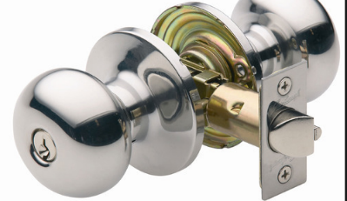
* Name plate with Aarohi Aram. Find out designs and how to fix it.
* All wall colors are white
* Thermal insulation of walls (inner or outer??? Mostly outer??) so that summer is not hot (optional) - don’t think there is space to do this. May be heat reflective coating is required.
* (no wireless) Doorbell which can be operated on / off. Like in rented house.
* Check for AC holes in both bedrooms. AC hole hall not required (after much consideration). IN future if required, make sure AC fan can be fit in patio and there is space,
* All shelves knob should be round. May be costly. But may not be strong enough. Check which one is better and use it.
* Transparent shelves wherever required. Since mostly It will be of off-white color, may be nor required everywhere.
* Take measurements of all existing items.
* Bed (80 x 40)
* God Shelf (30 x 24 x 14)
* Sofa
* Wood B Row (77 x 32 x 17)
* Cloth Shelf (blue) (27 x 14 x 14) for one shelf
* Buy ladder amazon
* Kitchen Shelves
* Make sure there is enough lighting and not cramped with shelves
* Place for grinder (40 x 23 x 31.5 cm, 9 kg)
* Black shade for window instead of curtain but not doable. No custom item. Difficult to wash. But curtain allow less light if not tied properly, or buy curtains with Velcro

# PICTURES

